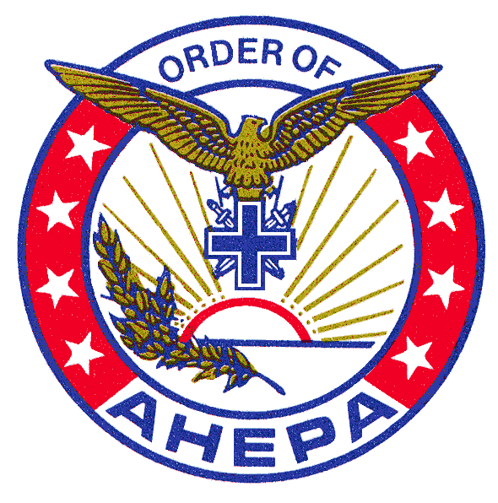

Officers

George W. Stratton
President
708/430-2240
Georstratt@aol.com

Angelo Versis
Vice-President
aversis@comcast.net

John Kasimos
Secretary
jkasimos@att.net

Nick Lamnatos
Recording Secretary
708/598-8537
nicklamnatos@yahoo.com

John Vranas
Treasurer
john@vranas.com

Directors

Louis Gust Atsaves
Evange Bozinis
Mike Cookas
Dr. Ioannis Dalapas
Peter G. Danos
Michael George Davros PHD
John Latsoudis
Peter Lekas
Dimitrios V. Mavraganis
Demetrios Pirpiris

13th District Governor

Themistocles Frangos

Emeritus Directors

Steve Manta

13th District AHEPA Scholarship Foundation Inc.
P.O. Box 576, Bedford Park, IL 60499-057

December 2020

Dear Chapter President/Secretary:

Applications are enclosed for the 13th District AHEPA Scholarship awards for the year 2021. Eligible student must be a high school senior, have a minimum four-year cumulative grade point average of B and be either of Greek heritage or have a parent that is an active member of the AHEPA family. Detailed eligibility requirements are listed on page one of the scholarship application.

Note that special provisions apply to students attending the Seminary and those that can demonstrate financial need.

Because the deadline for submitting applications is March 15th, 2021, we would appreciate that your Chapter promptly informing your members of this scholarship opportunity. Last year the AHEPA Foundation distributed 34 scholarships totaling $ 42,000 to eligible students.

Additional application forms may be obtained by photocopy, or by e-mailing nicklamnatos@yahoo.com or by going to the District’s webpage at www.ahepa.org/ and follow the prompts to District 13, Application for Scholarship or contacting us at the above address.

Very truly yours,

Nick C. Lamnatos
Foundation Secretary

